­­­**Project-Team: 1**

**Book my Show**

**Project Specification:**

* Responsive SPA using Angular.
* Application will support user and admin role. Use Angular either for admin or front end.
* Admin will add multiplexes details with City and specific location. E.g. Haryana, Gurgaon, sector 48 PVR
* Admin will add movies under various multiplexes with daily schedule.
* Multiple movies can be seen on home screen.
* Multiple movies are available in multiplex and corresponding schedule.
* User can filter movies based on their interest or movie category like comedy, action etc.
* User can book movie ticket based on the availability.
* Admin will manage ratings based on the reviews given by the users.
* Once done with booking, user will get confirmation mail on user registered email ID.

**Project Requirement**

1. **Angular 13**
2. **JSON**
3. **Rest Web Services API**

**Modules:**

1. Homepage
2. Registration
3. Login
4. Movies List
5. Movie Details
6. Cities List
7. Theaters List
8. Seats Selection
9. Payment
10. Success payment
11. Cancellation

**Design:**

1. Home page

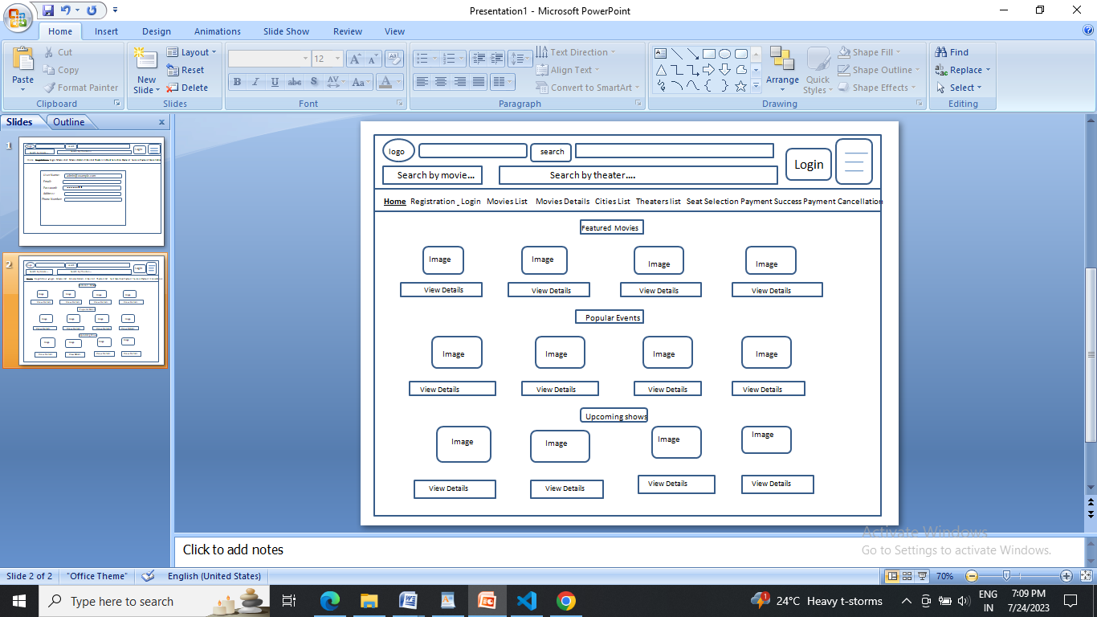

1. Registration

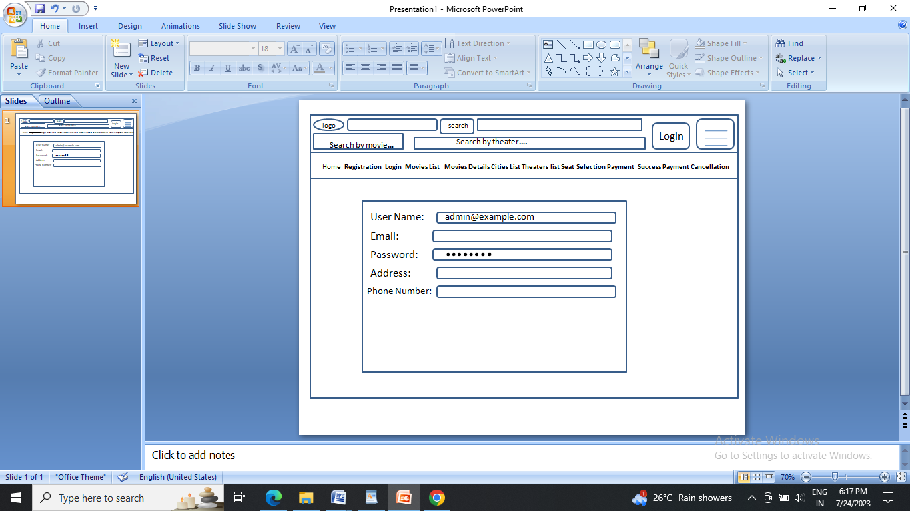

1. Login

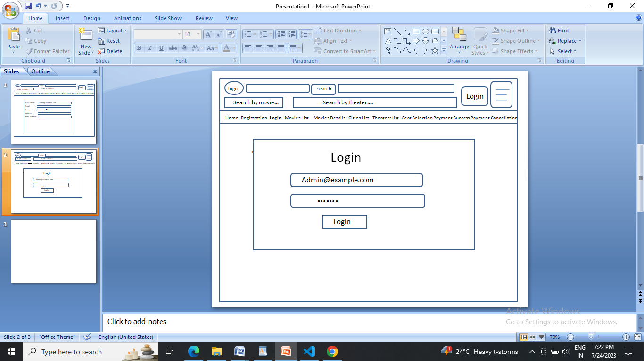

1. Movie List

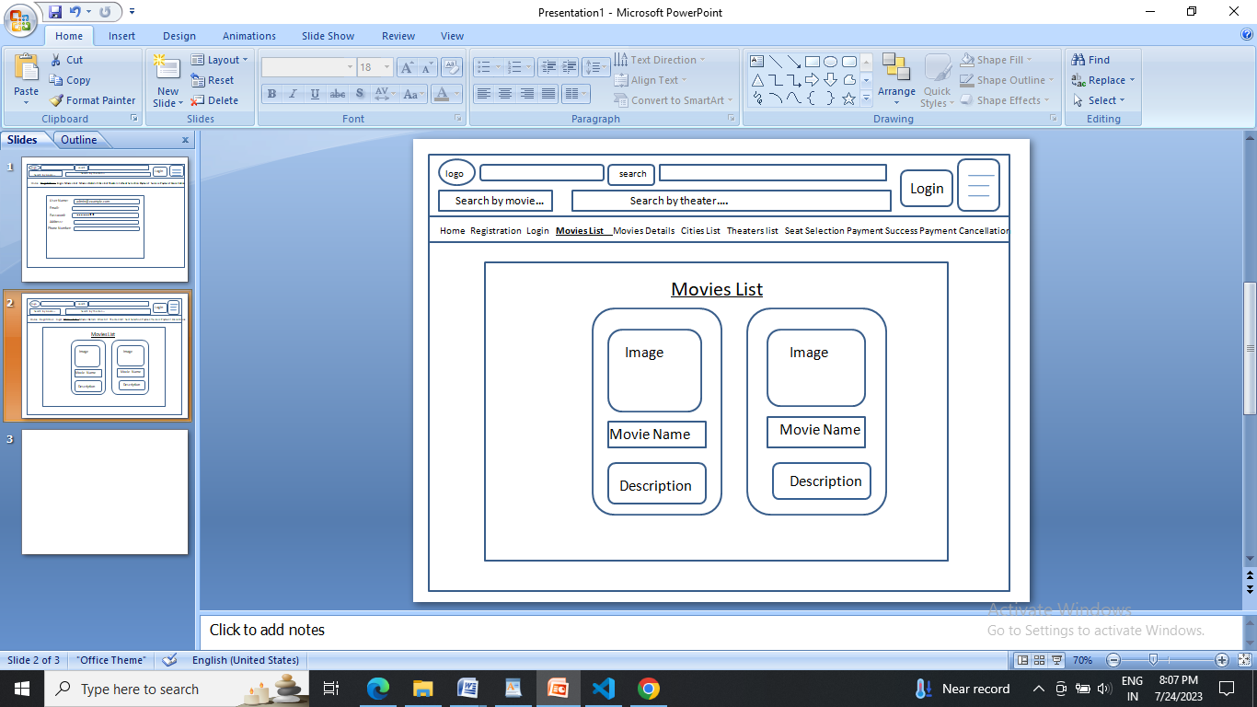

1. Movie Details

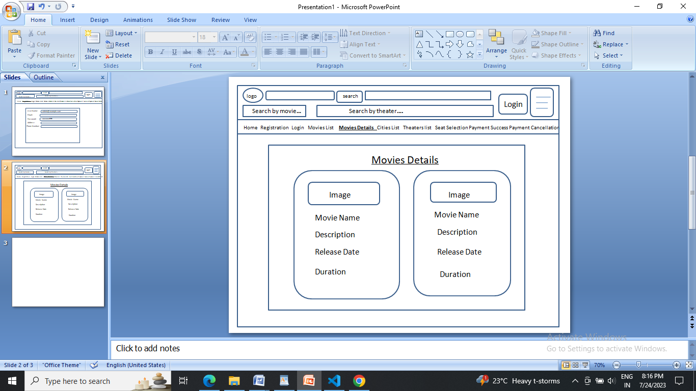

1. Cities List

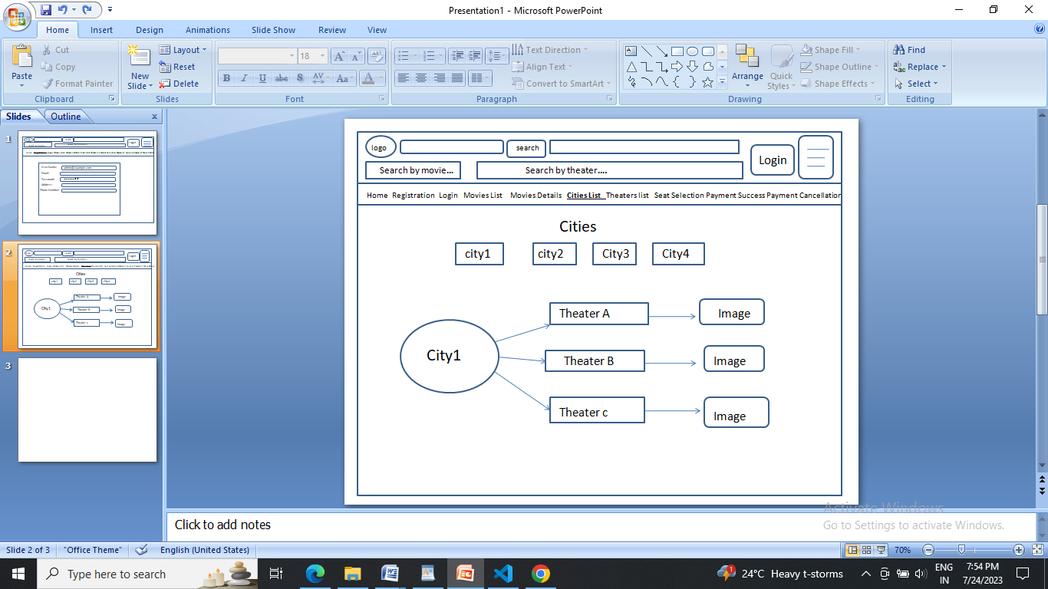

1. Theaters List

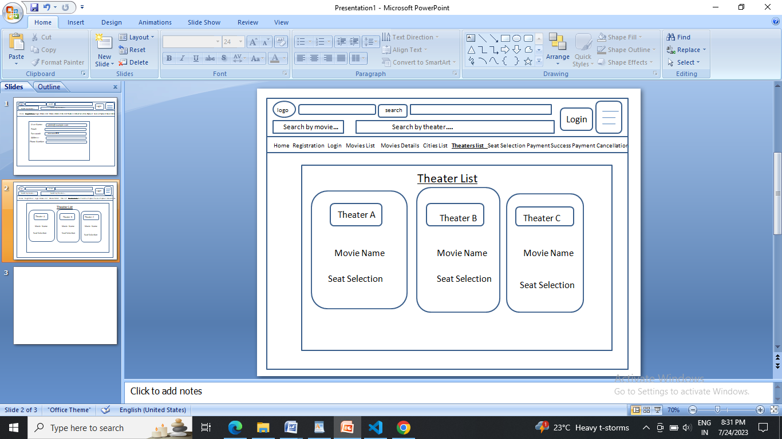

1. Seat Selection

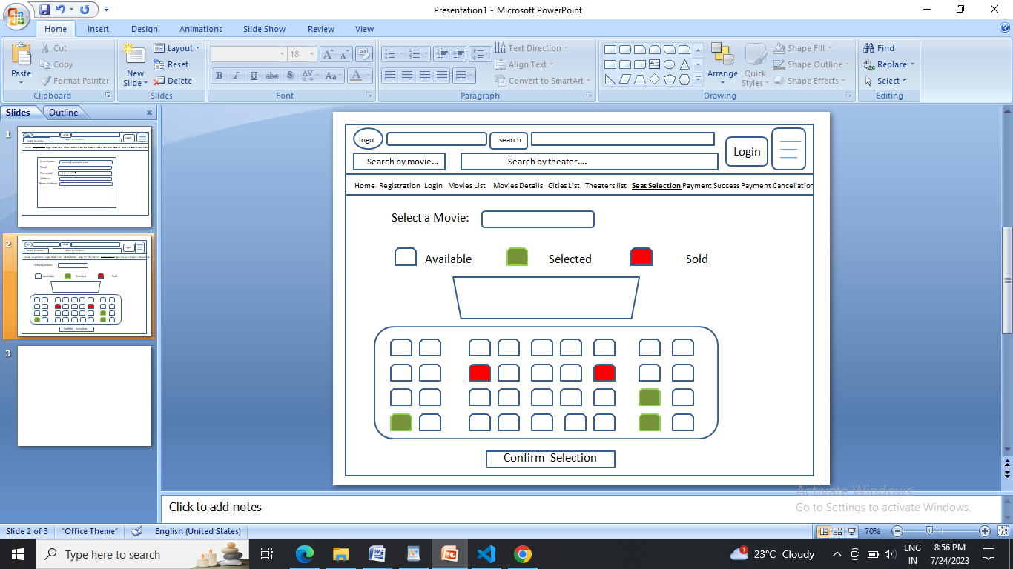

1. Payment

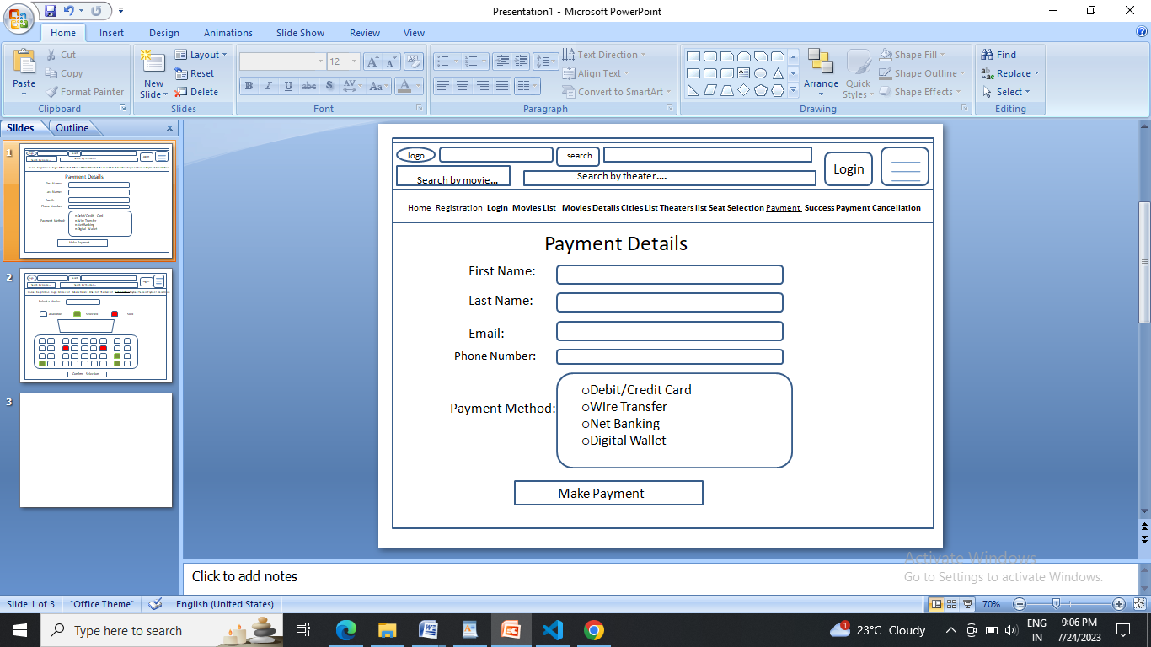

10. Successful Payment

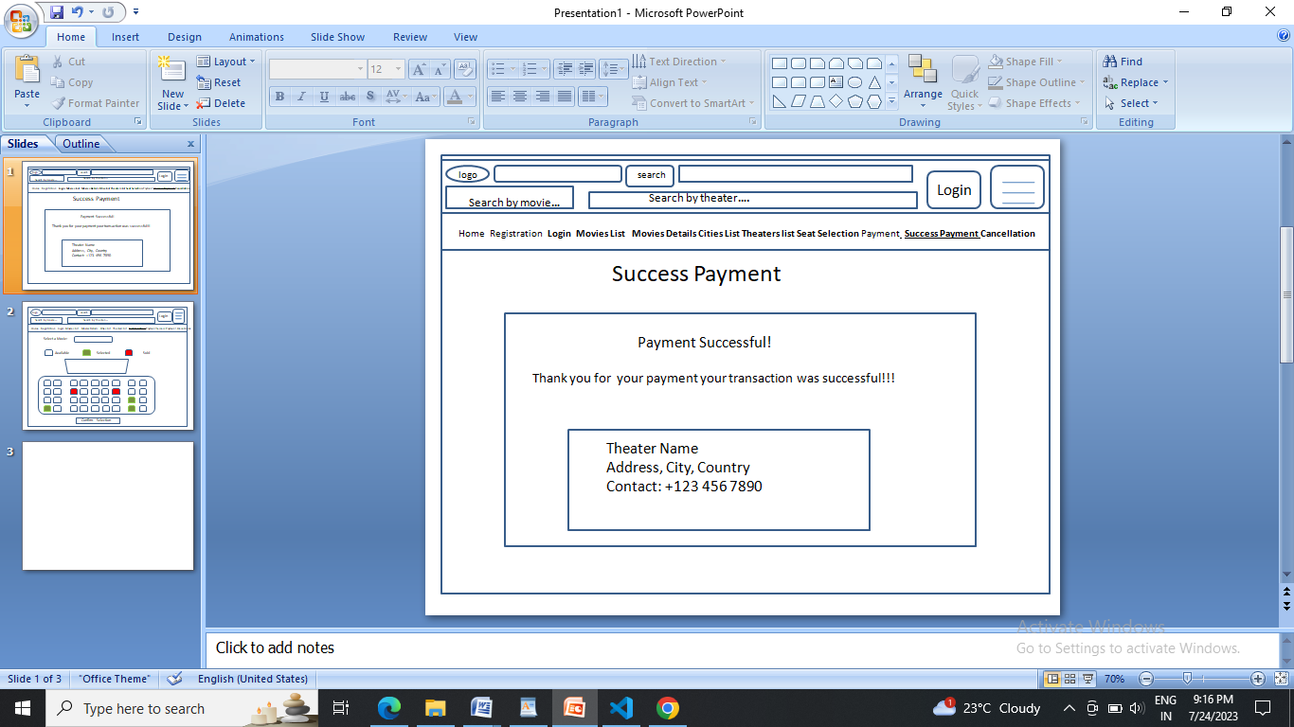

10.Cancellation

